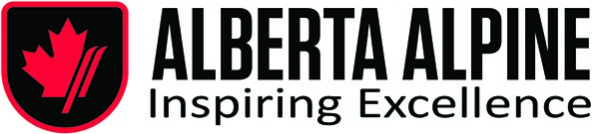

September 22, 2022
The Nominating Committee’s nominees for election to the Board at the September 28 AGM are as follows:

Dan Berry
Geoff Irwin
Charles Gushaty
Marian Yuzda
Dan Jalbert
Jeff Swanson
Chris Scheele

The Annual General Meeting (the “Meeting”) of the Members of Alberta Alpine Ski Association (the “Society”), will be held Wednesday, the 28th day of September 2022, at the hour of 7:00 PM (Mountain Time)

Please join our meeting via Zoom:
https://dentons.zoom.us/j/91916793540?pwd=T3pNb21Gemd3SG90YWxkRktNSSs3dz09

Meeting ID: | 919 1679 3540
Passcode: | 828082

Thank you.

